Диаграмма классов

@startuml

class HomePage {

+pcSpecs: List<PC>

+services: List<Service>

+photos: List<Photo>

+displayPCSpecs(): void

+displayServices(): void

+displayPhotos(): void

}

class News {

+esportsNews: List<NewsItem>

+clubNews: List<NewsItem>

+displayEsportsNews(): void

+displayClubNews(): void

}

class Tournaments {

+tournamentNews: List<NewsItem>

+displayTournamentNews(): void

}

class FAQ {

+faqItems: List<FaqItem>

+displayFAQs(): void

}

class Contacts {

+address: String

+phone: String

+email: String

+organizationName: String

+inn: String

+ogrn: String

+postalAddress: String

+contactForm: ContactForm

+displayContacts(): void

+submitForm(): void

}

class Footer {

+socialLinks: List<SocialLink>

+clubPhone: String

+clubName: String

+clubEmail: String

+displayFooter(): void

}

class PC {

+processor: String

+graphicsCard: String

+ram: String

+storage: String

}

class Service {

+name: String

+description: String

+price: Float

}

class Photo {

+filePath: String

+description: String

}

class NewsItem {

+title: String

+content: String

+date: Date

}

class FaqItem {

+question: String

+answer: String

}

class ContactForm {

+name: String

+email: String

+question: String

+submit(): void

}

class SocialLink {

+platformName: String

+url: String

}

HomePage "1" -- "many" PC

HomePage "1" -- "many" Service

HomePage "1" -- "many" Photo

News "1" -- "many" NewsItem

Tournaments "1" -- "many" NewsItem

FAQ "1" -- "many" FaqItem

Contacts "1" -- "1" ContactForm

Footer "1" -- "many" SocialLink

@enduml

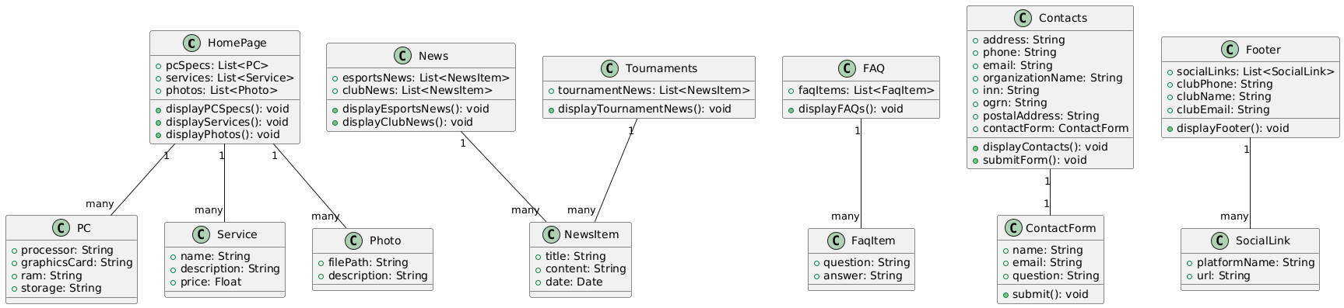

Диаграмма компонентов

@startuml

package "Frontend" {

[Home Page Component]

[News Component]

[Tournaments Component]

[FAQ Component]

[Contacts Component]

[Footer Component]

}

package "Backend" {

[Database]

[Email Service]

}

[Home Page Component] --> [Database] : Fetches PC Specs, Services, Photos

[News Component] --> [Database] : Fetches Esports and Club News

[Tournaments Component] --> [Database] : Fetches Tournament News

[FAQ Component] --> [Database] : Fetches FAQs

[Contacts Component] --> [Database] : Fetches Contact Info

[Contacts Component] --> [Email Service] : Sends Contact Form Responses

@enduml